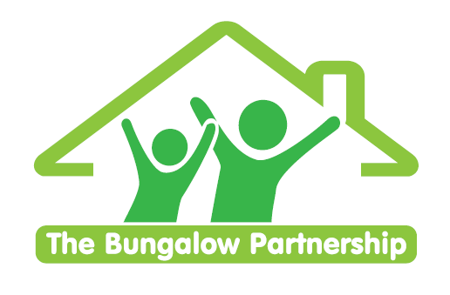

TRAINING EVENT
21st October 2026

NON-PROFIT ORGANISATION

Using Therapeutic Stories to Reach Children and Young People and to Help Them Tell Their Story

Led by Clare Sullivan (Psychotherapeutic Counsellor, Trainer and Therapeutic Team Manager)

Venue The Bungalow Partnership. Rosewood School Site. The Garth. Coulby Newham. Middlesbrough. TS8 0UG

Wednesday 21st October 2026 1-3.30pm

Therapeutic Stories can help children and young people to resolve confusions and uncertainty in a child friendly way that is both engaging and anxiety reducing. Alongside the many off the shelf therapeutic stories available, Clare supports participants to consider writing their own personalised therapeutic stories for or with the children and young people they support. Every story allows us to identify with characters, identify skills and qualities that we possess and often under appreciate, and resolve conflicts and worries along the way. There is a grounding effect of therapeutic stories and sharing a journey with a trusted adult. It can create a space for the child to experience someone similar to themselves and who can overcome adversity and realise their strengths.

This course will enable you to:
Understand the effectiveness and structure of therapeutic stories.
Explore the benefits of therapeutic stories for children of all ages.
Understand how sharing therapeutic stories can be therapeutic and healing.
Learn how to be curious about how therapeutic stories can unlock pain and confusion and promote resilience.
£75.00 per delegate
To book your place contact us at training@thebungalowpartnership.org
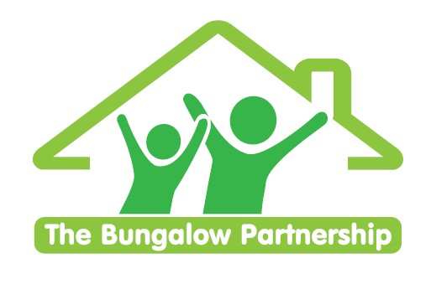
  TRAINING EVENTS
  BOOKING FORM
CONTACT DETAILS
School/Organisation:_________________________________________________________________
Address: ________________________________________________________________________
________________________________________________________________________
Telephone: _____________________________ Email: ___________________________________
Contact: _______________________________Position in School: __________________________
Authorised by: __________________________Signature: __________________________________
TRAINING EVENT  Using Therapeutic Stories to Help Children Tell Their Story  £75.00 per delegate | 21st October 2026 1-3.30pm
DELEGATES

Name Email:
- _________________________________ ____________________________________________
- _________________________________ ____________________________________________
- _________________________________ ____________________________________________

TOTAL COST £ ______________
Please return completed booking form and accompanying Purchase Order (if required) to:
The Bungalow Partnership  Rose Wood Academy  The Garth  Coulby Newham  Middlesbrough  TS8 0UG  Tel: 01642 595363  Email: training@thebungalowpartnership.org | 

