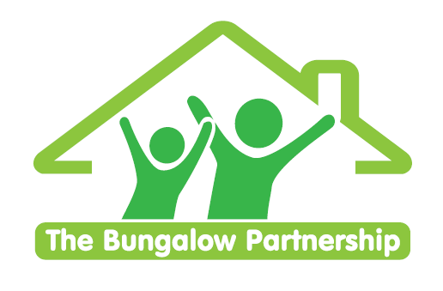

ONLINE TRAINING EVENT
8th July 2026

Supporting Those Who Support Others
NON-PROFIT ORGANISATION

Summer Self-Care Online Workshop
(Taking Care of Your Wellbeing on the Approach to the summer holidays)
Led by Clare Sullivan (Psychotherapeutic Counsellor, Trainer and Therapeutic Team Manager)
Wednesday 8th July 2026 3.30-4.30pm (ONLINE)

This workshop is for anyone wanting to take care of their own wellbeing on the run up to the summer holidays. Working with children, young people and families can be emotionally demanding and all too often we reach the summer break exhausted and in need of recovery. This workshop aims to ensure that Practitioners are emotionally well as they take time off with their families and/or friends and to ensure they can then benefit from their time off.

This 1-hour online workshop offers a supportive and practical space for adults working with children—whether in education, care, healthcare, or community settings—to reflect on and recharge their own wellbeing during the busy and often emotionally charged lead-up to the summer period. Participants will explore the impact of impending transitions and end of year pressures on their physical, emotional, and mental health, and learn simple, sustainable self-care practices to help them stay grounded, resilient, and present for the children in their care.

Learning Objectives:
By the end of this workshop, participants will be able to:
1. Recognise the unique challenges and stressors experienced by adults supporting
children during the summer months.
2. Understand the importance of personal wellbeing in sustaining compassionate and
effective support for children.
3. Identify personal signs of stress, fatigue, or emotional overload.
4. Explore simple, adaptable self-care strategies that fit into busy routines and support
mental and emotional resilience.
£35.00 per delegate
To book a place please contact
thebungalowpartnership@gmail.com

Did you know that every time you attend one of our training workshops, you are directly supporting our work with local children, young people and families?
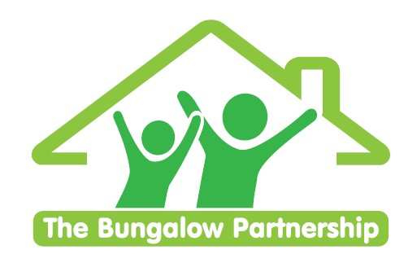
  ONLINE TRAINING EVENTS
  BOOKING FORM
CONTACT DETAILS
School/Organisation:________________________________________________________
Address: __________________________________________________________________

Telephone: _____________________________ Email: _______________________
Contact: _______________________________Position in School: __________________
Authorised by: __________________________Signature: _________________________
TRAINING EVENT £35.00 per delegate  Summer Self Care Workshop | ONLINE  Wednesday 8th July 2026  3.30-4.30pm

DELEGATES
Name Email:
- _________________________________ _____________________________________
- _________________________________ _____________________________________
- _________________________________ _____________________________________
TOTAL COST £ ______________
Please return completed booking form and accompanying Purchase Order (if required) to:  The Bungalow Partnership  Rose Wood Academy  The Garth  Coulby Newham  Middlesbrough  TS8 0UG  Tel: 01642 595363  Email: thebungalowpartnership@gmail.com | 