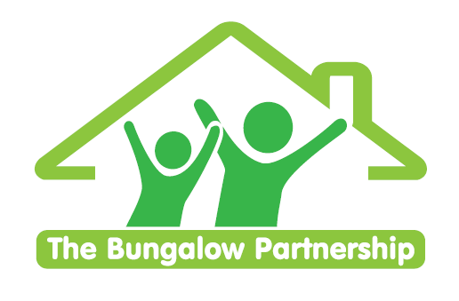

ONLINE TRAINING EVENT
15th June 2026

Supporting Those Who Support Others
NON-PROFIT ORGANISATION

An introduction to safely and sensitively supporting children who display problematic eating behaviours
Led by Clare Sullivan (Psychotherapeutic Counsellor, Trainer and Therapeutic Team Manager)
ONLINE
Monday 15th June 2026 5pm - 6pm
This 1-hour online workshop provides a compassionate and practical introduction to understanding and responding to problematic eating in children and young people. Aimed at professionals in education, youth work, social care, and family support, the session explores the emotional, social, and developmental factors that may underlie unhealthy eating behaviours. This is an awareness-raising session designed to build confidence and improve early response.
Participants will learn how to spot early warning signs, approach sensitive conversations, and provide appropriate support within their role. The session will also highlight the importance of creating safe, non-judgmental environments and knowing when to involve specialist services.
Learning Outcomes:
By the end of this workshop, participants will be able to:
- Recognise common signs and behaviours that may indicate problematic eating in children and young people.
- Understand key psychological, emotional, and social factors that can contribute to unhealthy eating patterns.
- Approach conversations about food, body image, and eating with sensitivity, care, and without reinforcing shame or stigma.
- Support young people by promoting body neutrality, positive relationships with food, and emotional regulation strategies.
£35.00 per delegate
To book a place please contact
thebungalowpartnership@gmail.com

Did you know that every time you attend one of our training workshops, you are directly supporting our work with local children, young people and families?
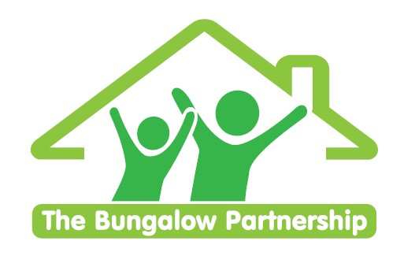
  ONLINE TRAINING EVENTS
  BOOKING FORM
CONTACT DETAILS
School/Organisation:________________________________________________________
Address: __________________________________________________________________

Telephone: _____________________________ Email: _______________________
Contact: _______________________________Position in School: __________________
Authorised by: __________________________Signature: _________________________
TRAINING EVENT £35.00 per delegate  Eating Disorders | ONLINE  Monday 15th June 2026  5pm – 6pm

DELEGATES
Name Email:
- _________________________________ _____________________________________
- _________________________________ _____________________________________
- _________________________________ _____________________________________
TOTAL COST £ ______________
Please return completed booking form and accompanying Purchase Order (if required) to:  The Bungalow Partnership  Rose Wood Academy  The Garth  Coulby Newham  Middlesbrough  TS8 0UG  Tel: 01642 595363  Email: thebungalowpartnership@gmail.com | 

