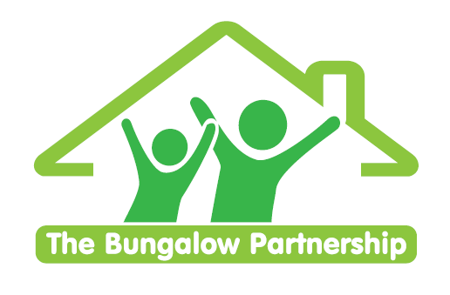
ONLINE TRAINING EVENT
3rd June 2026 3.30—4.30pm

Supporting Those Who Support Others
An introduction to safely and sensitively supporting children who Self Harm
Led by Clare Sullivan — Psychotherapeutic Counsellor, Trainer & Therapeutic Team Manager
Wednesday 3rd June 2026 3.30-4.30pm
ONLINE
This introductory training session equips educators, youth workers, caregivers, and frontline professionals with foundational knowledge and practical guidance on how to respond appropriately, safely, and compassionately when a child discloses self-harm.
Participants will explore the emotional, psychological, and developmental factors behind self-harming behaviour, understand their role in the response process, and learn how to create a supportive environment for disclosure. The session emphasizes safeguarding procedures, trauma-informed practice, and effective communication skills to ensure the child's wellbeing is prioritised at all times.
This training is for you if you want to …
- Understand common signs and motivations behind self-harm in children and young people.
- Demonstrate appropriate verbal and non-verbal communication techniques when a child discloses self-harming behaviour.
- Respond in a calm, non-judgmental, and supportive manner that prioritises the child’s emotional safety.
- Understand the importance of boundaries, confidentiality, and mandatory reporting in the context of self-harm disclosures.

£35.00 per delegate
To book a place please contact
thebungalowpartnership@gmail.com
Did you know that every time you attend one of our training workshops, you are directly supporting our work with local children, young people and families?

TRAINING EVENTS
BOOKING FORM
CONTACT DETAILS
School/Organisation:________________________________________________________
Address: ________________________________________________________________________
Telephone: _____________________________ Email: ______________________________
Contact: _______________________________Position in School: ____________________
Authorised by: __________________________Signature: __________________________
TRAINING EVENT £35 per delegate Supporting Young People
with Self Harm
ONLINE
3.06.2026
3.30-4.30pm
DELEGATES
Name Email:
- _________________________________ _____________________________________
- _________________________________ ____________________________________
- _________________________________ _____________________________________
TOTAL COST £ ______________
Please return completed booking form and accompanying Purchase Order (if required) to:
The Bungalow Partnership  Rose Wood Academy  The Garth  Coulby Newham  Middlesbrough  TS8 0UG  Tel: 01642 595363  Email: thebungalowpartnership@gmail.com | 