
TRAINING EVENT
28th April 2026

Supporting Those Who Support Others
AUTISM SERIES: Mental Health and Support Needs in Autistic Young People
Led by Stacey Majoros — Autism Consultant
28th April 2026 1-3pm
Venue: The Bungalow Partnership. Rosewood School Site. The Garth. Coulby Newham. Middlesbrough. TS8 0UG

The Final of our 2025/6 Autism Workshops and the topic being explored is – Mental Health and Support Needs in Autistic Young People
The workshops are designed for TA's, SEN staff, Support Workers and Teachers to come together as a group, learn from our Autism Consultant Stacey Majoros and develop skills and confidence to support the young people in your school.
Past attendees of Stacey's workshops have welcomed the opportunity to join a small group of like-minded practitioners who share good practice and come away with strategies and approaches to help compliment or develop SEN provision in their schools.
This is the Final of a series of 7 workshops arranged. The workshops can be attended as a one off event at a cost of £35 per attendee or practitioners can sign up for all 7 workshops at a reduced total cost of £210.00.
The workshops will take place at The Bungalow Partnership, Rosewood School Site, The Garth, Coulby Newham, Middlesbrough. TS8 0UG. 28th April 2026 1-3pm
To book your place, please contact The Bungalow Partnership on 01642 595363 or email thebungalowpartnership@gmail.com

£35.00 per delegate
To book a place please contact
thebungalowpartnership@gmail.com
Did you know that every time you attend one of our training workshops, you are directly supporting our work with local children, young people and families?

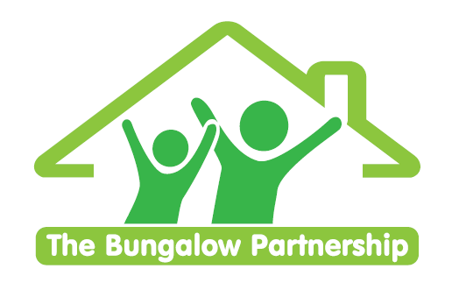
TRAINING EVENTS
BOOKING FORM
CONTACT DETAILS
School/Organisation:________________________________________________________
Address: ________________________________________________________________________
Telephone: _____________________________ Email: ______________________________
Contact: _______________________________Position in School: ____________________
Authorised by: __________________________Signature: __________________________
TRAINING EVENT £35 per delegate
Mental Health and Support Needs in Autistic Young People
Venue:The Bungalow Partnership
28th April 2026
1-3pm
DELEGATES
Name Email:
- _________________________________ _____________________________________
- _________________________________ ____________________________________
- _________________________________ _____________________________________
TOTAL COST £ ______________
Please return completed booking form and accompanying Purchase Order (if required) to:
The Bungalow Partnership
Rose Wood Academy
The Garth
Coulby Newham
Middlesbrough
TS8 0UG
Tel: 01642 595363
Email: thebungalowpartnership@gmail.com

