
TRAINING EVENT
22nd October 2025

Supporting Those Who Support Others
Regulating The Teenage Brain

Led by Clare Sullivan — Psychotherapeutic Counsellor, Trainer & Therapeutic Team Manager
Wednesday 22nd October 2025 5.30-6.30pm
Online

This twilight micro training session provides practitioners with an opportunity to explore the unique phase of re-development of the teenage brain and how to respond to teenagers so that they feel heard, understood and respected. By connecting with teenagers in a way that provides them with a sense of connection and validity, we are better able to help their regulation of emotions and behaviours.

This training is for you if you want to …

- Understand the unique phase of brain development that young people experience as they reach adolescence and how to support a smooth transition through this tricky developmental stage.
- Gain awareness and confidence in responding to teenagers with coregulation and respect for where they are now.
- Consider the role of emotional regulation in soothing and dampening alerted states and how to scaffold opportunities for the development of resilience and confidence.
£35.00 per delegate
To book a place please contact
thebungalowpartnership@gmail.com
Did you know that every time you attend one of our training workshops, you are directly supporting our work with local children, young people and families?

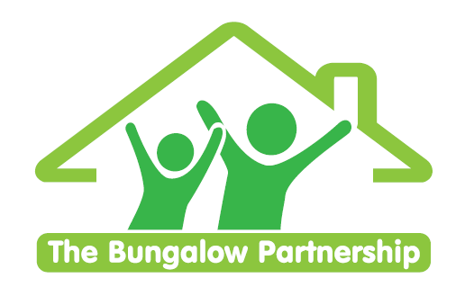
TRAINING EVENTS
BOOKING FORM
CONTACT DETAILS
School/Organisation:________________________________________________________
Address: ________________________________________________________________________

Telephone: _____________________________ Email: ______________________________
Contact: _______________________________Position in School: ____________________
Authorised by: __________________________Signature: __________________________
TRAINING EVENT £35.00 per delegate Regulating the Teenage Brain
Online
22nd October 2025
5.30-6.30pm
DELEGATES
Name Email:
- _________________________________ _____________________________________
- _________________________________ ____________________________________
- _________________________________ _____________________________________
TOTAL COST £ ______________
Please return completed booking form and accompanying Purchase Order (if required) to:
The Bungalow Partnership
Rose Wood Academy
The Garth
Coulby Newham
Middlesbrough
TS8 0UG
Tel: 01642 595363
Email: thebungalowpartnership@gmail.com

