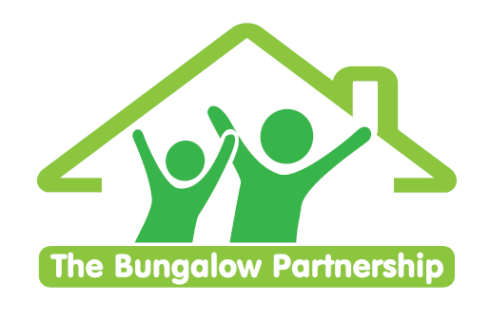

TRAINING EVENT
Wednesday 26th April 2023

**Limited Places— Book now to avoid disappointment **
NON-PROFIT ORGANISATION

Making and Using Puppets
for Children and Young People in Therapy

Led by Cathie Sprague — Dramatherapist
Wednesday 26th April 2023 1-3pm

Venue: Barnardo’s Bridgeway Project, Tees Valley Services, Allendale Rd, Ormesby, Middlesbrough TS7 9LF

This is an experiential workshop for teachers and therapists which will explore….

- What is a puppet? Why Puppets?
- Making a puppet - participants will have a choice between 2 different types of puppet to create and take away with you.
- Techniques for using puppets, e.g. hot seating, dramatic encounters.
- What puppets can tell us about a child/young person and their development.

£57.00 per delegate
Includes taking home puppets created within the session

To book a place please contact
thebungalowpartnership@gmail.com

This training is in high demand and places are limited so book early to avoid disappointment.

TRAINING EVENTS
BOOKING FORM

CONTACT DETAILS
School/Organisation:_________________________________________________________________
Address: ________________________________________________________________________
________________________________________________________________________
Telephone: _____________________________ Email: ___________________________________
Contact: _______________________________Position in School: __________________________
Authorised by: __________________________Signature: __________________________________
TRAINING EVENT £57.00 per delegate

Making and Using Puppets for Children and Young People in Therapy | - Wednesday 26th April 2023

DELEGATES

Name Email:
- _________________________________ ____________________________________________
- _________________________________ ____________________________________________
- _________________________________ ____________________________________________

TOTAL COST £ ______________

Please return completed booking form and accompanying Purchase Order (if required) to:
The Bungalow Partnership
Rose Wood Academy
The Garth
Coulby Newham
Middlesbrough
TS8 0UG
Tel: 01642 595363
Email: thebungalowpartnership@gmail.com

